**MA374 Lab- 6**

Aman Bucha

200123006

**Question 1:**

Some of the plots for the data in bsedata1 is as follows :

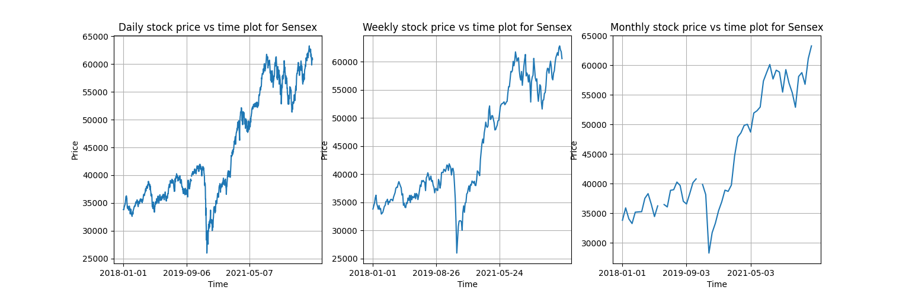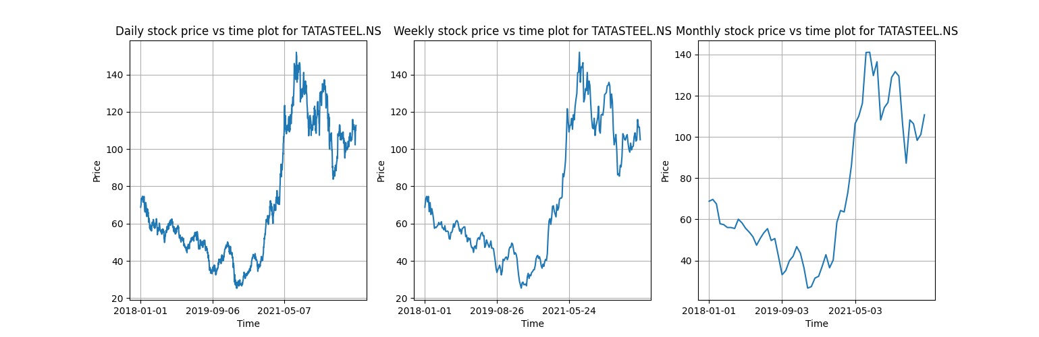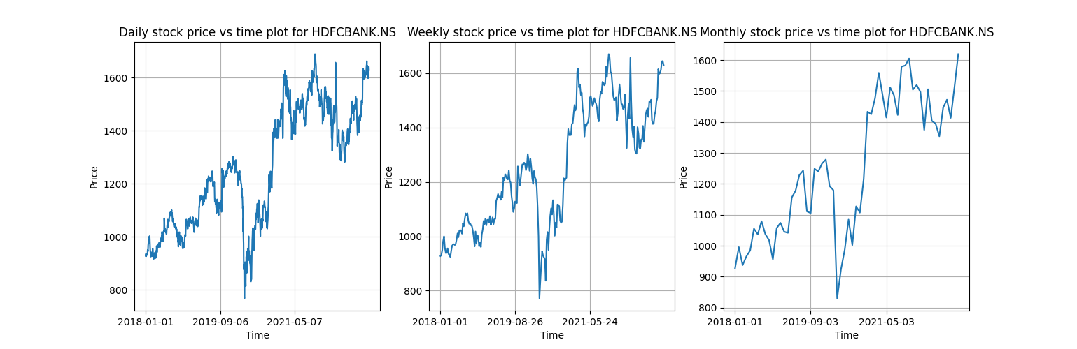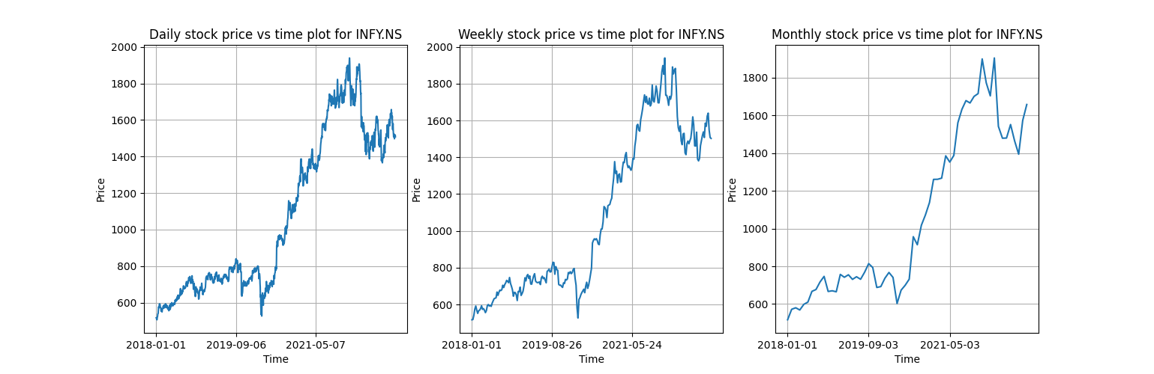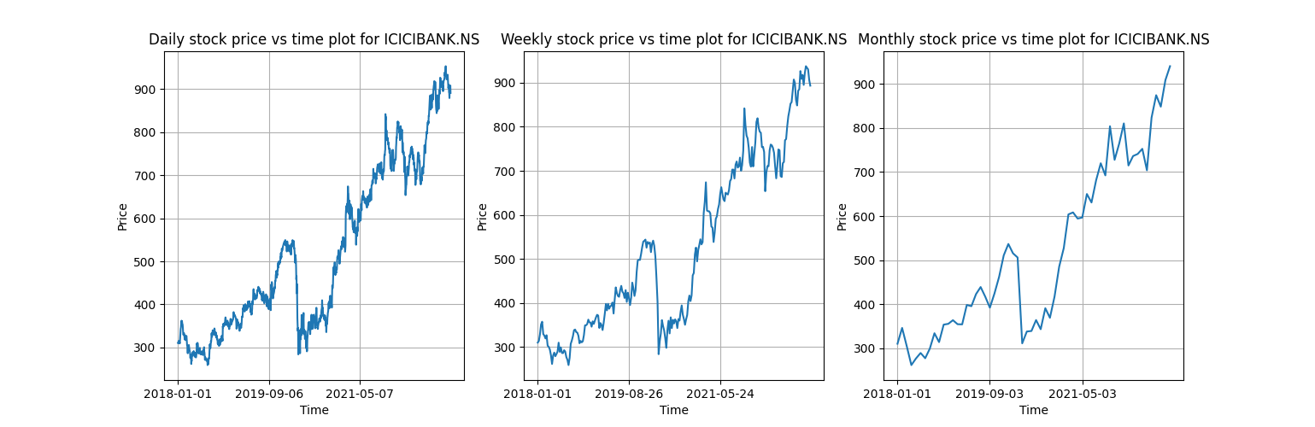

Some of the plots for nsedata1 are:

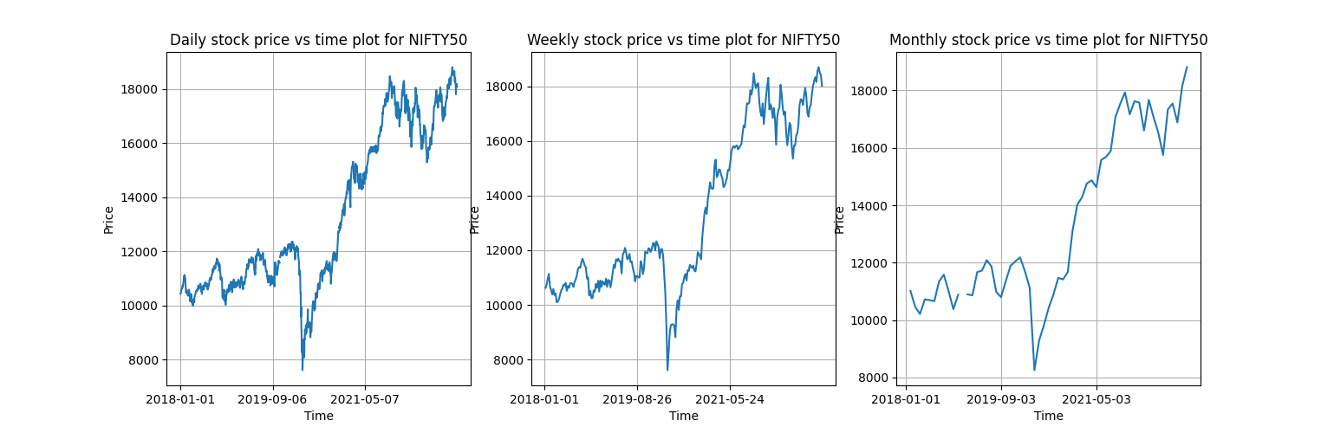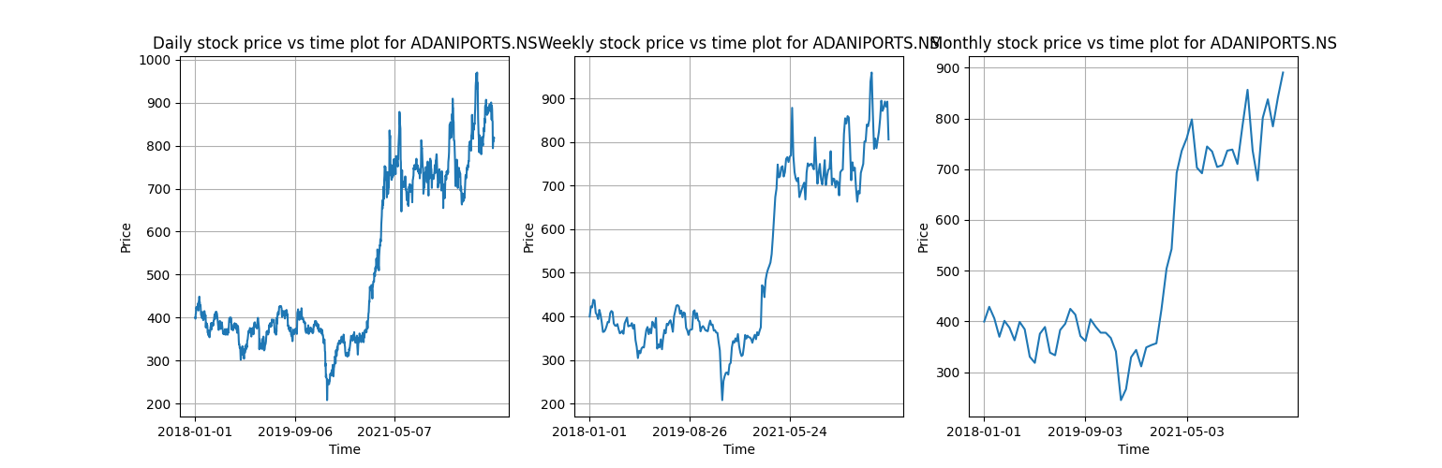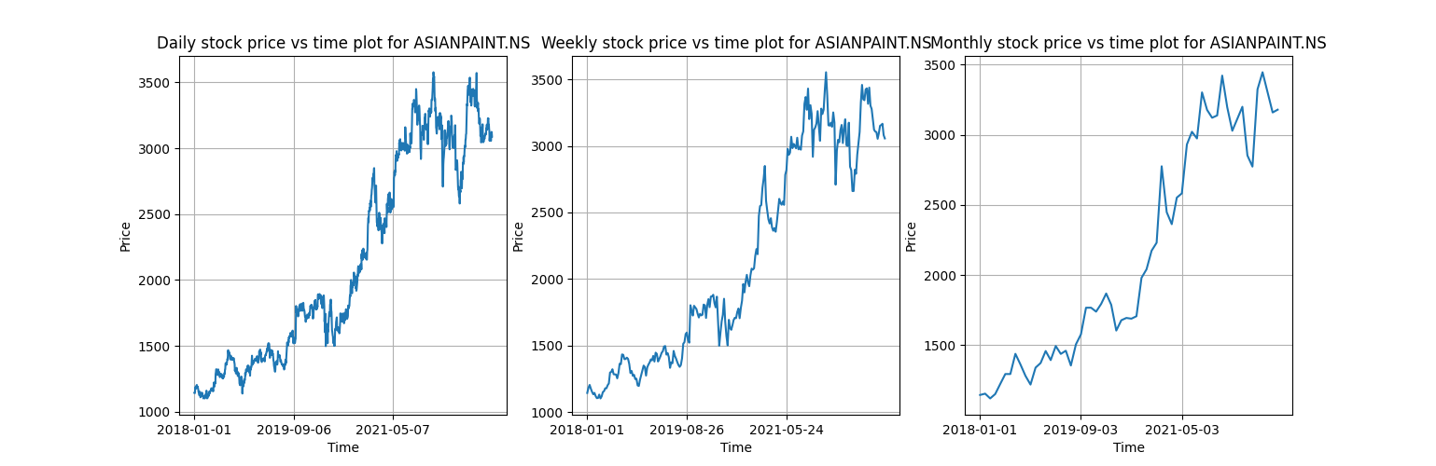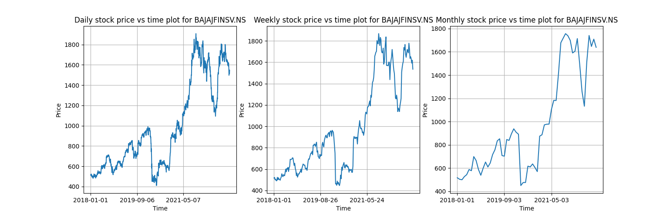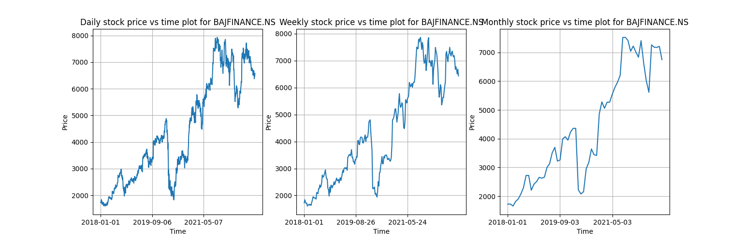

**Question 2:**

Some of the histogram plots of the normalized returns superimposing in a graph of the density function N (0, 1) for the data in bsedata1 are:

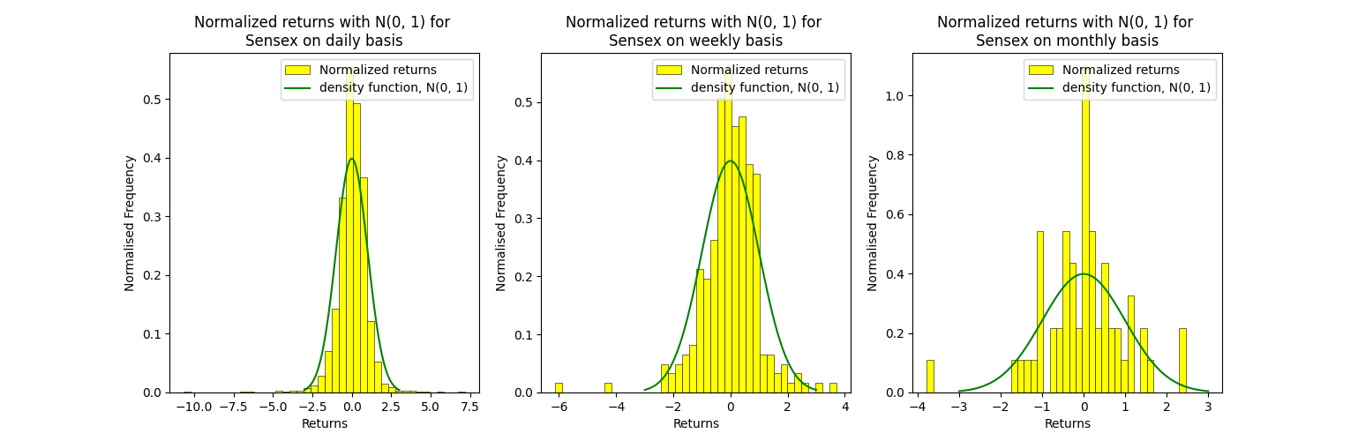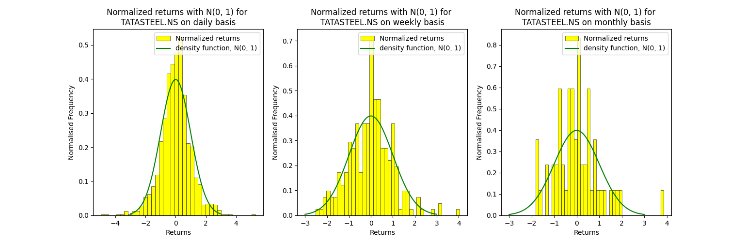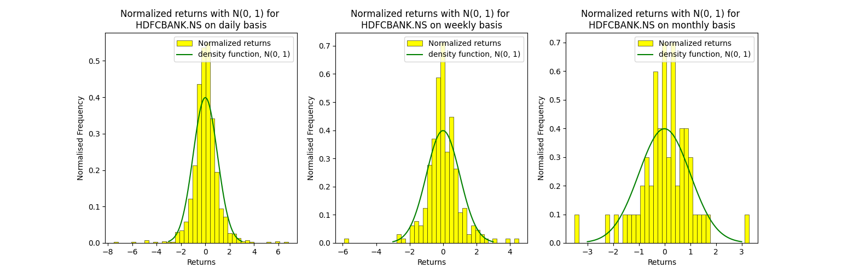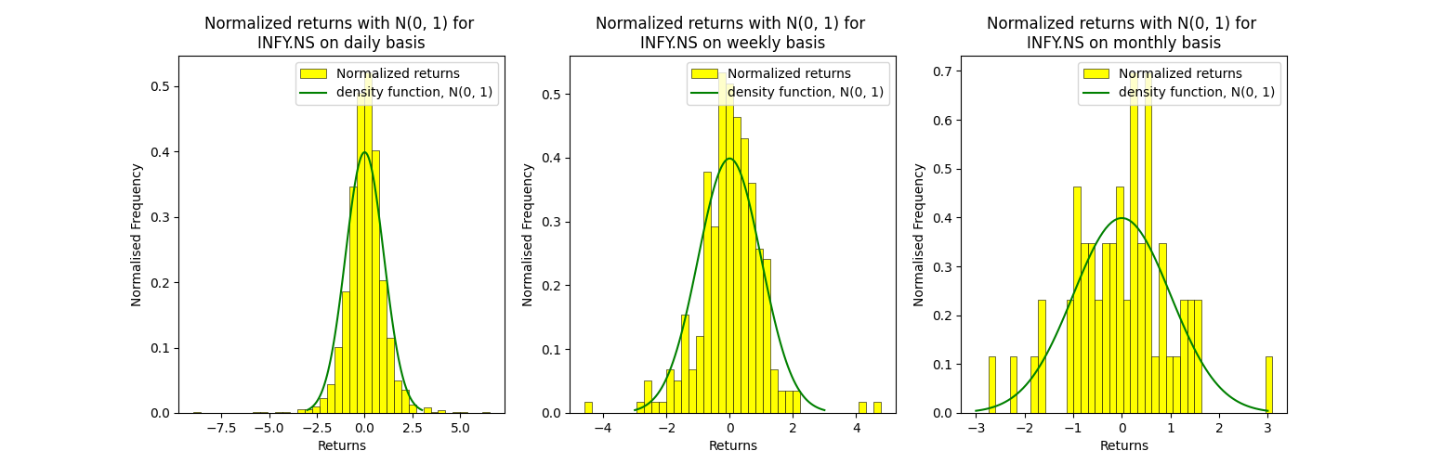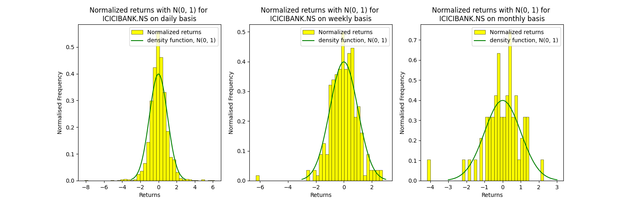

and the same for nsedata1 are:

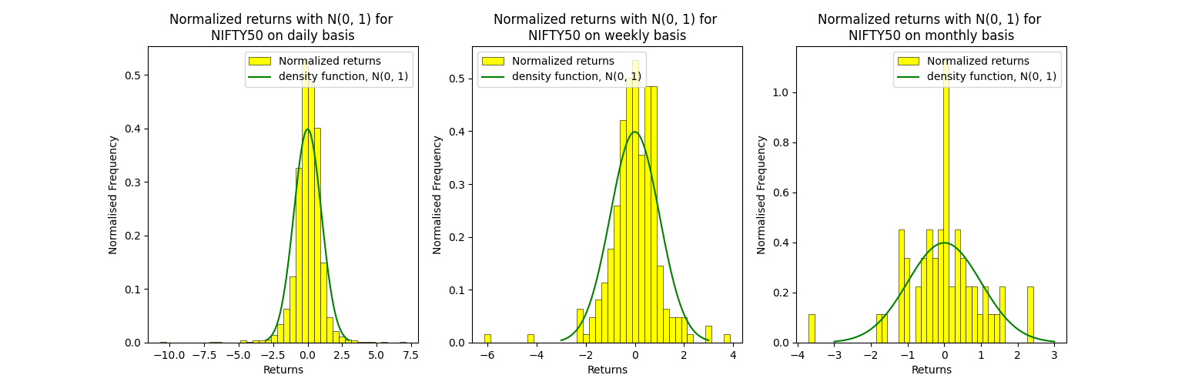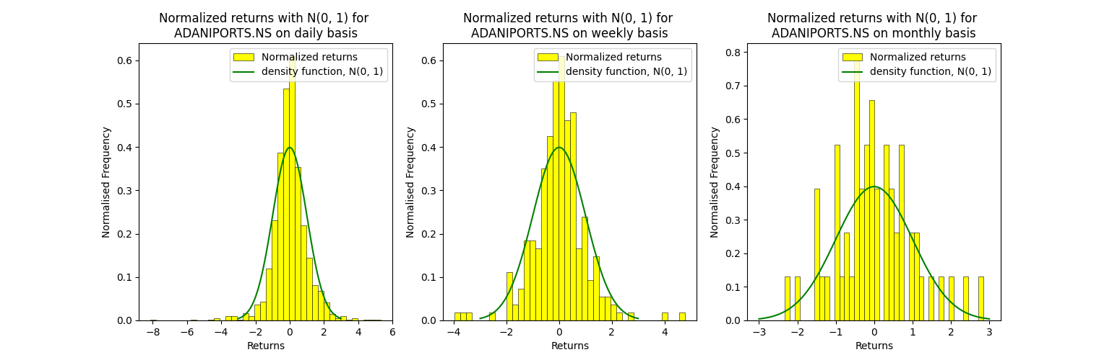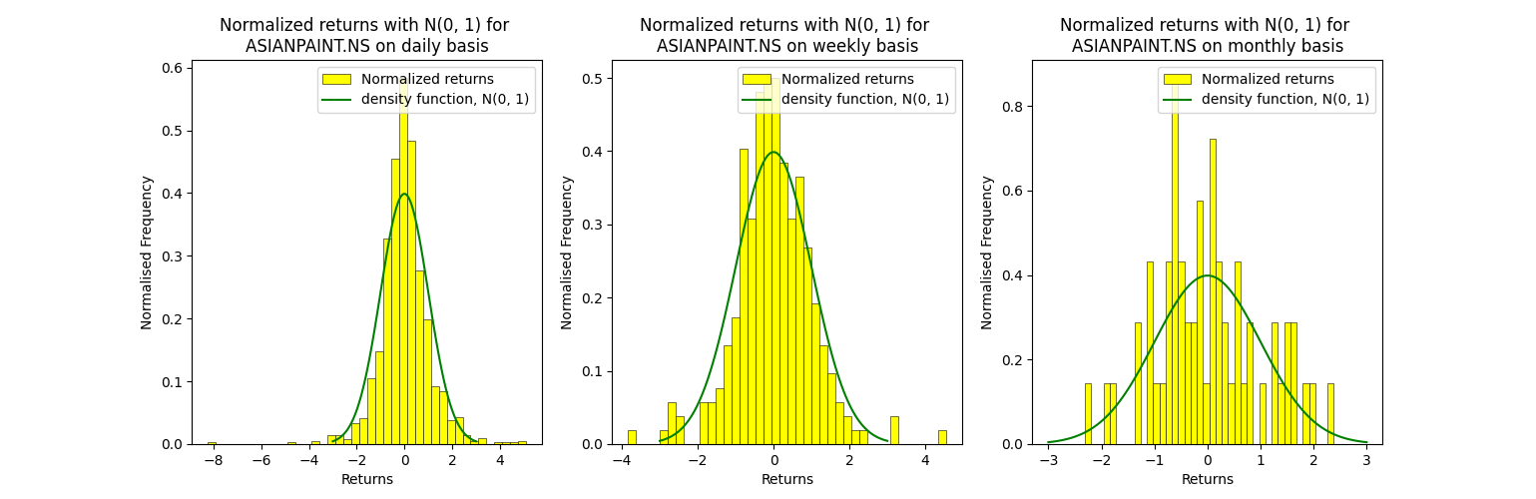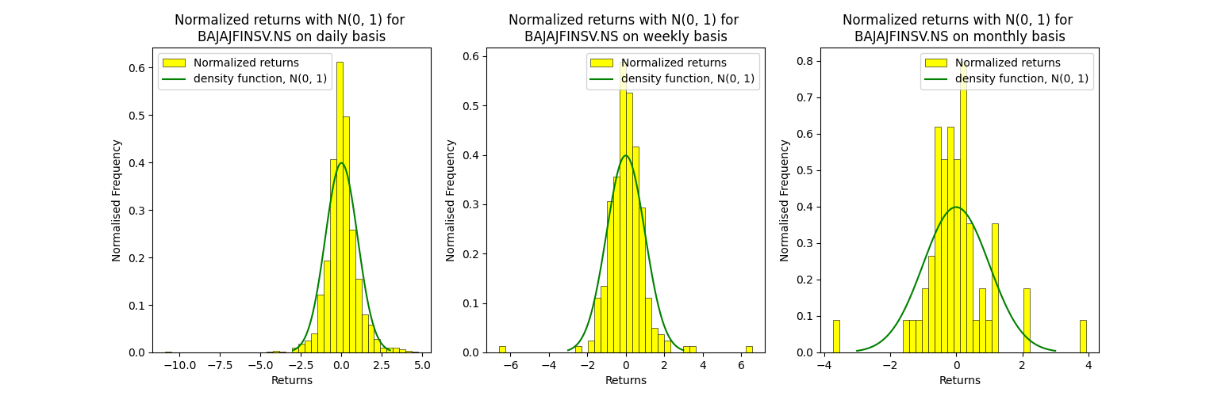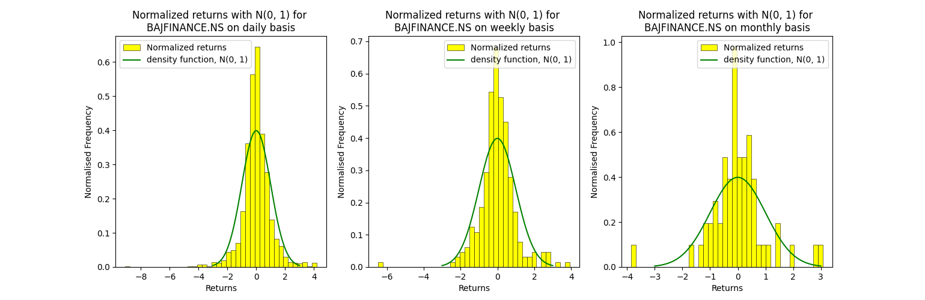

Now the corresponding boxplot of the normalized return of some of the stocks of bsedata1 are as follows:

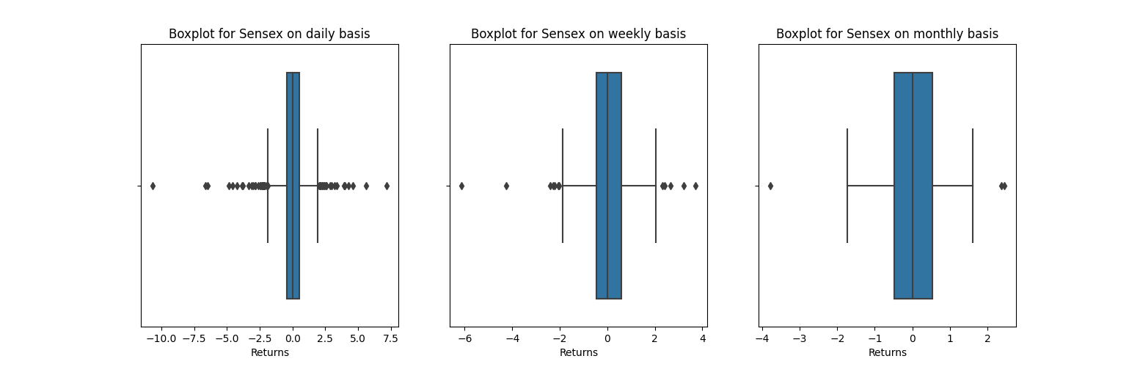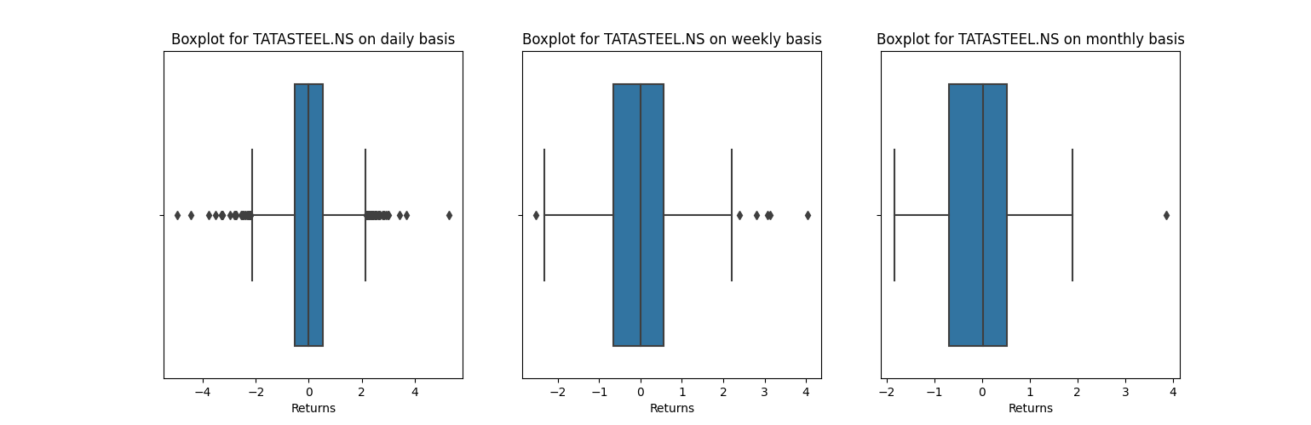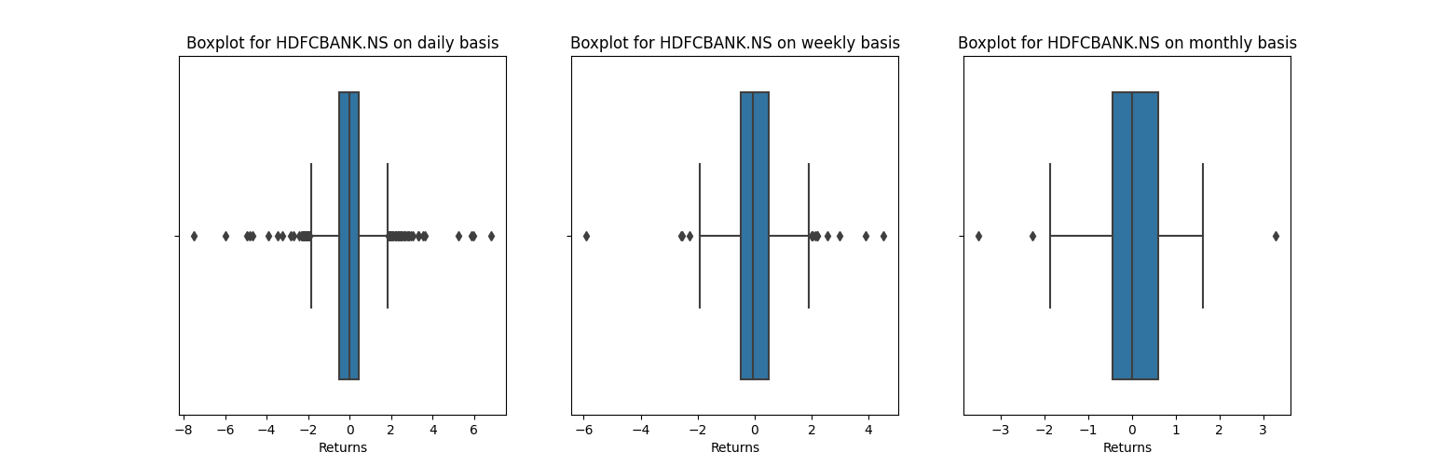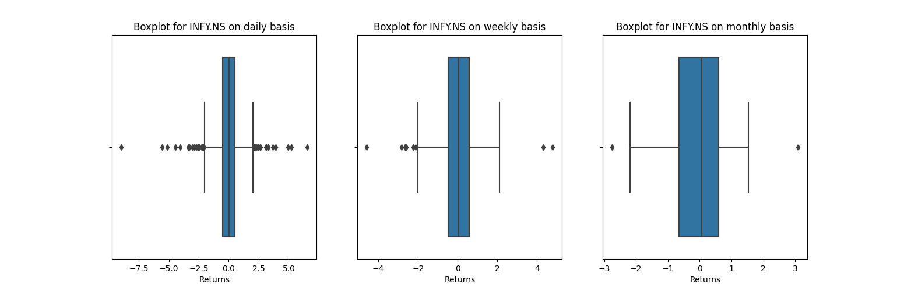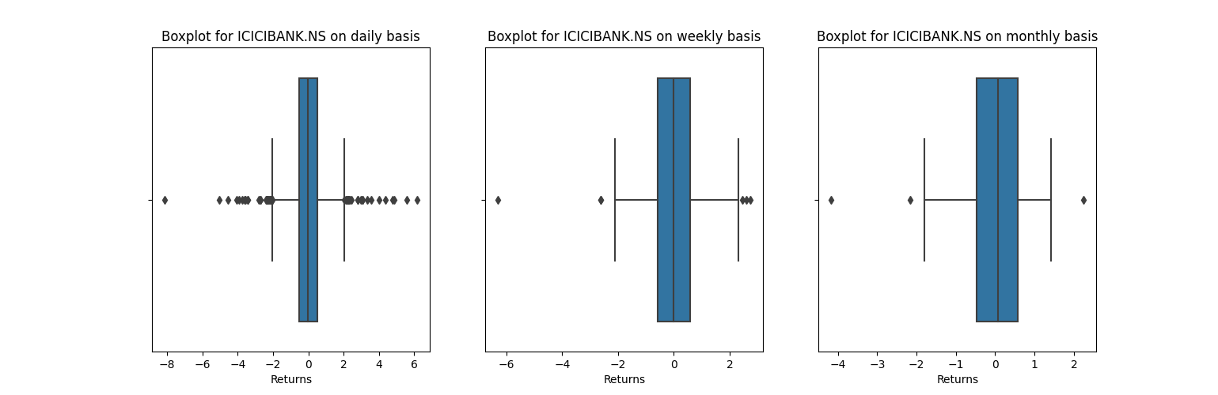

And the same for nsedata1 are:

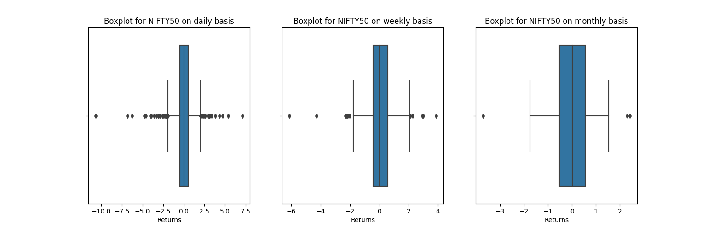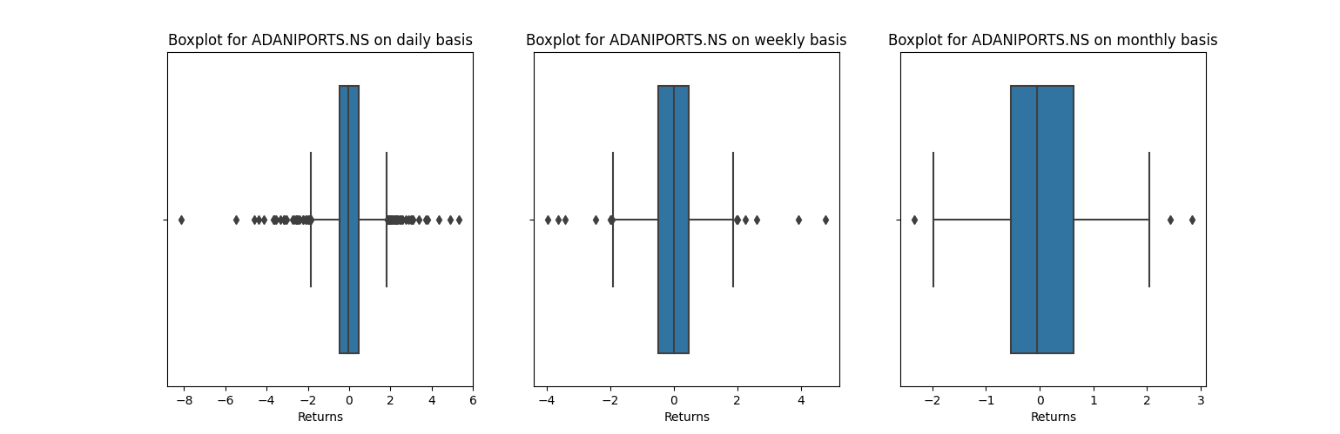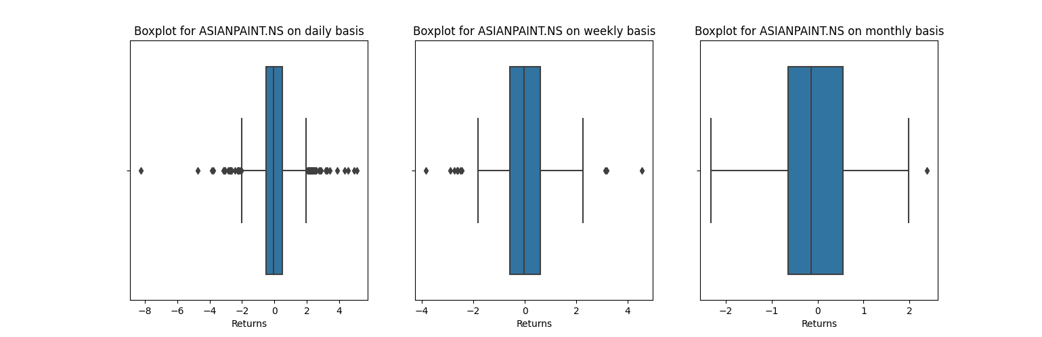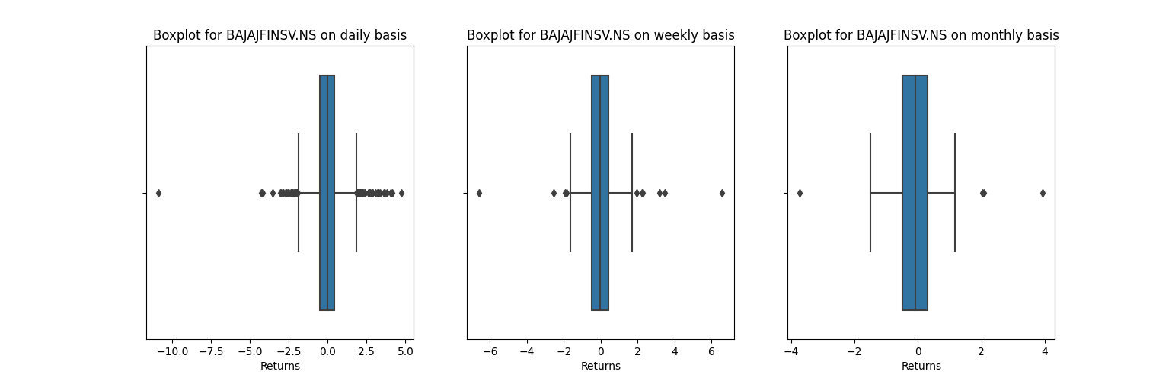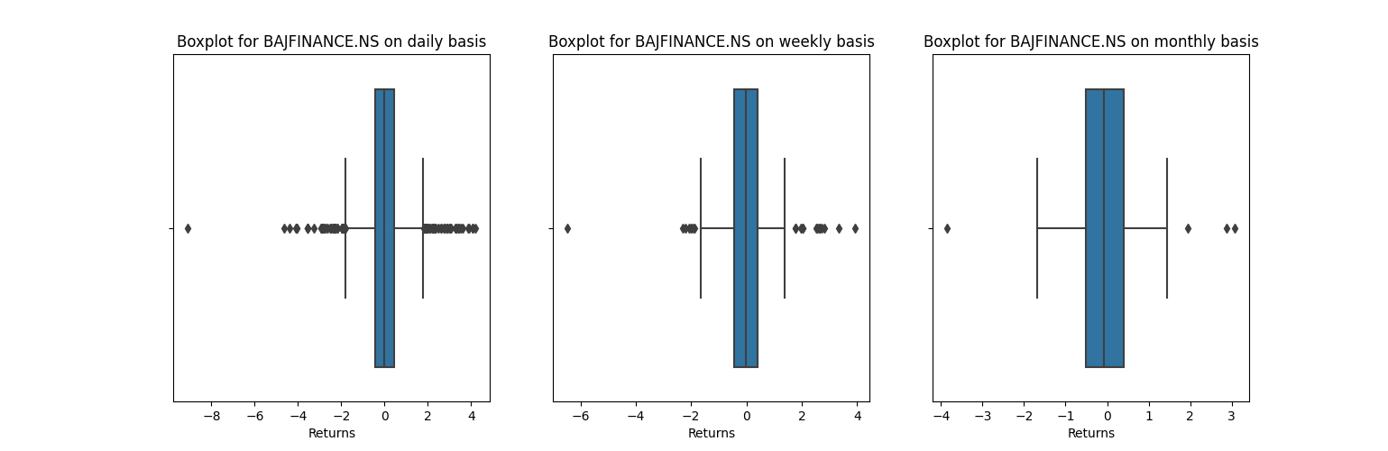

**Observations –**

1. We can observe that the N(0, 1) roughly estimates the normalized returns, which is more accurate if the returns are computed on daily basis instead of weekly or monthly.
2. The deviations are due to the random fluctuations in the real world market, so, naïve Gaussian distribution can’t completely model it.
3. It is more evident when a closer look is taken at the tails of these plots. The curve for N(0, 1) steeply decreases to 0, but the returns on the prices does not. At the tails, there seem to be more deviations, and more proper model using a mix of different distributions is required to capture those changes.
4. Such a behaviour is called as leptokurtic, i.e., high peaks and heavy tails. Jump diffusion model (by Merton) take these so called jumps at the tails into account.

**Question 3:**

The similar plots for the log returns for the data in bsedata1 are:

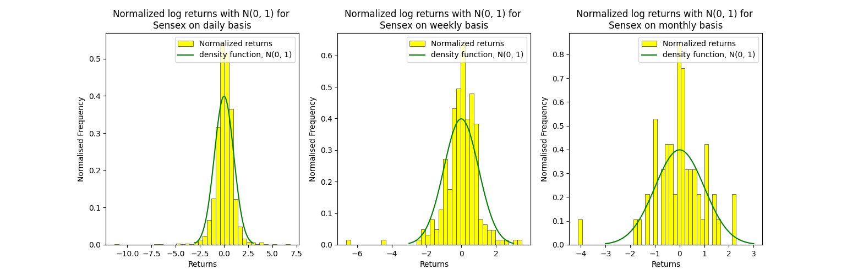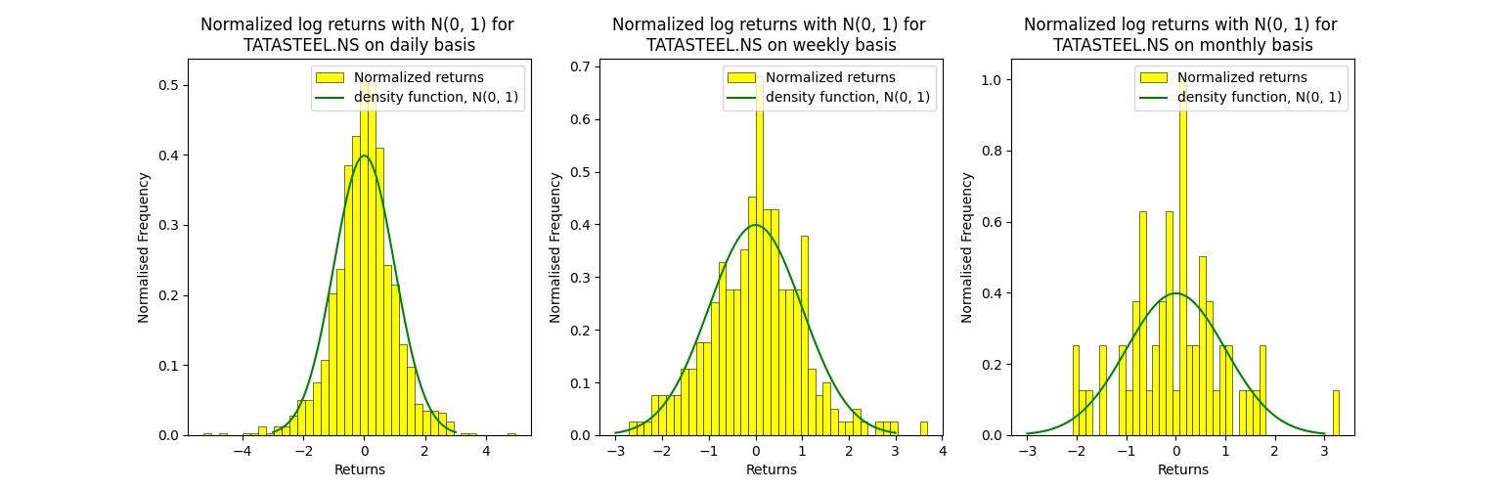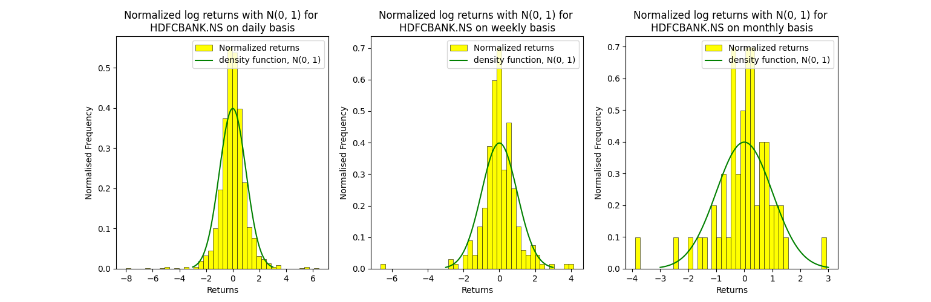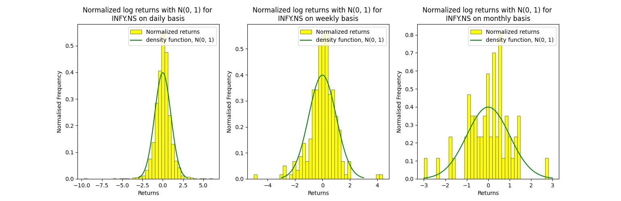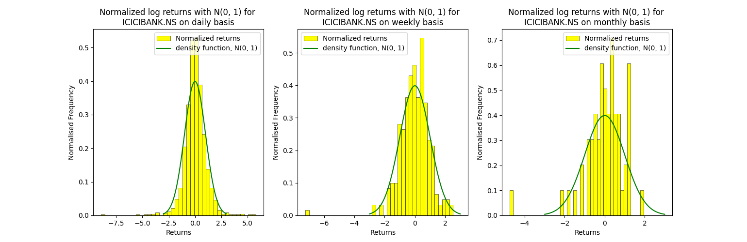

And for the data of nsedata1 are:

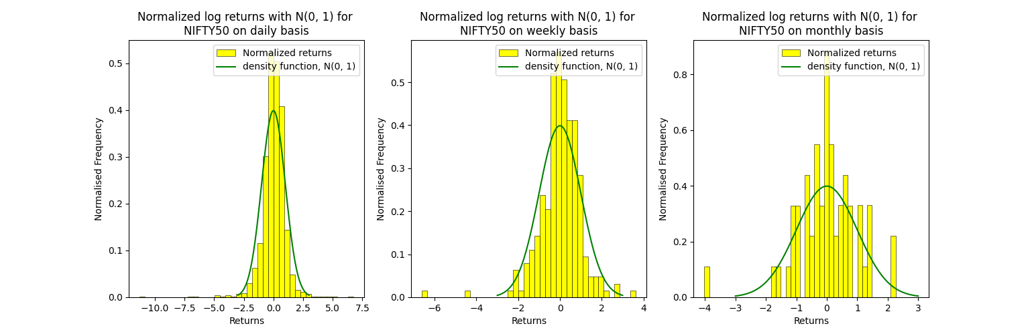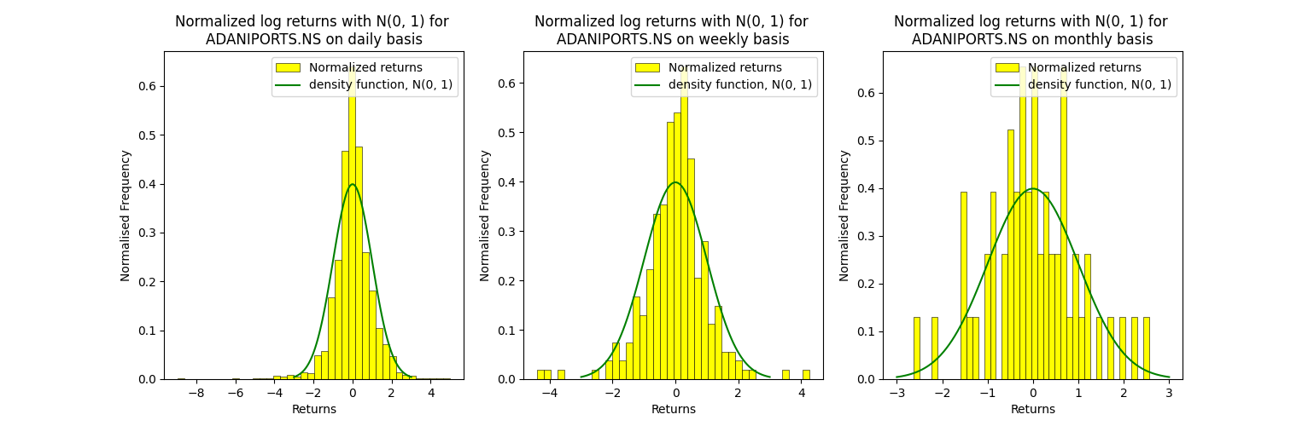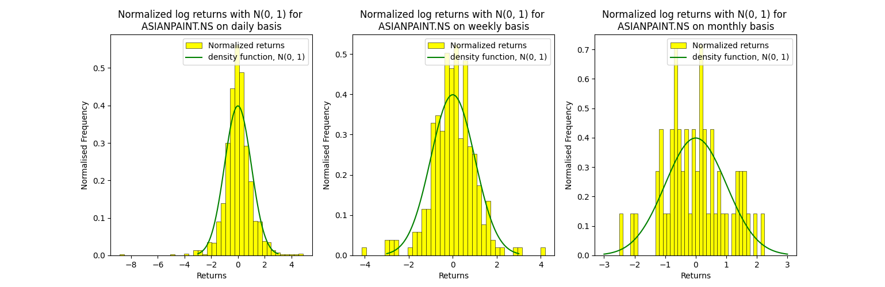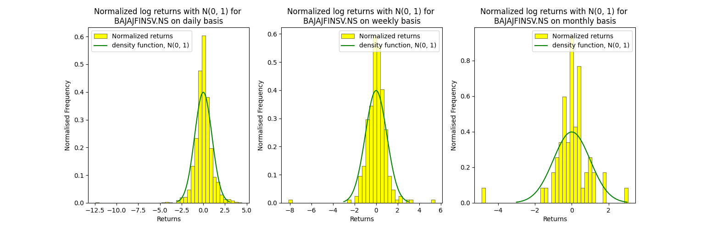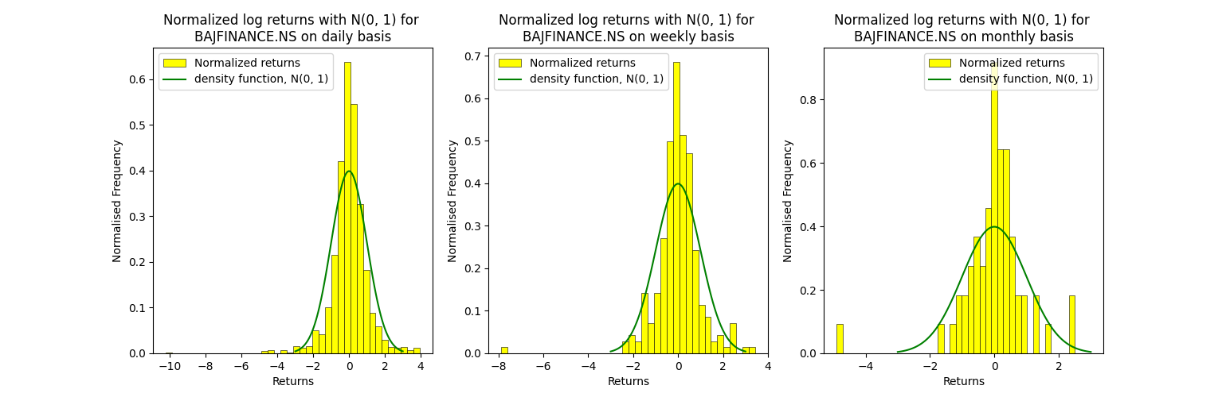

**Question 4 and 5:**

**Formulae used** –

* Geometric Brownian motion is used to model the scenario since stock prices behave like a stochastic process:



* 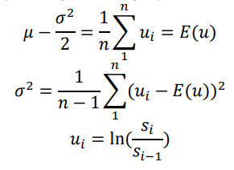

where,

Z1, Z2, …, Zn are independent N(0, 1) variables, ui is the log return of day i, and si and si-1 are adjacent closing stock prices of day i - 1 and day i respectively

For daily stock data:

The generated stock prices path along with the actual path for stocks in bsedata1 are:

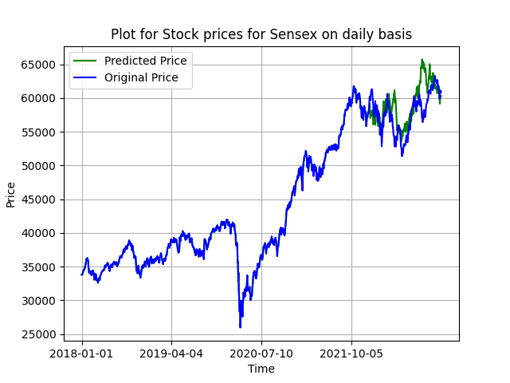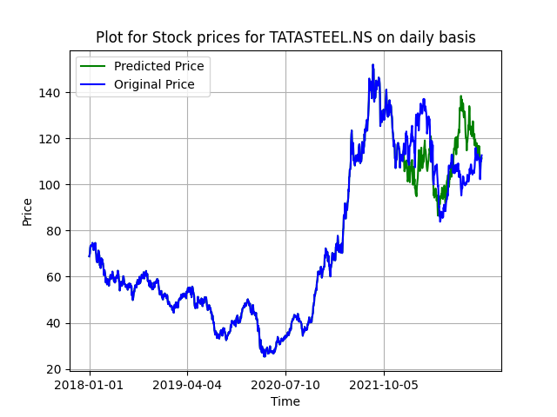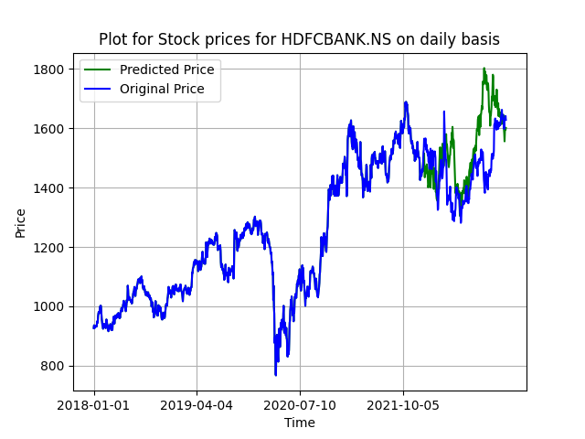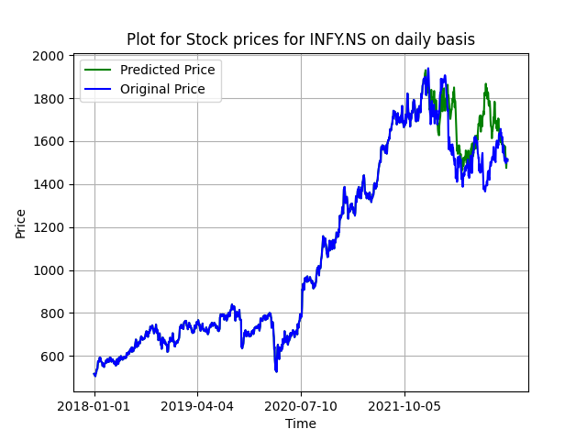

The generated stock prices path along with the actual path for stocks in nsedata1 are:

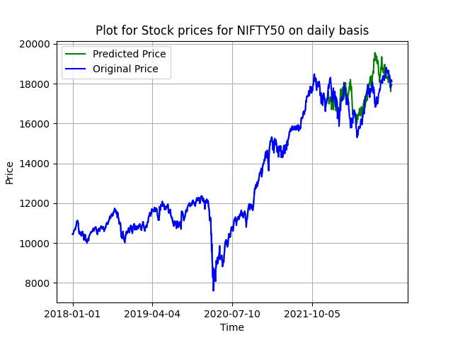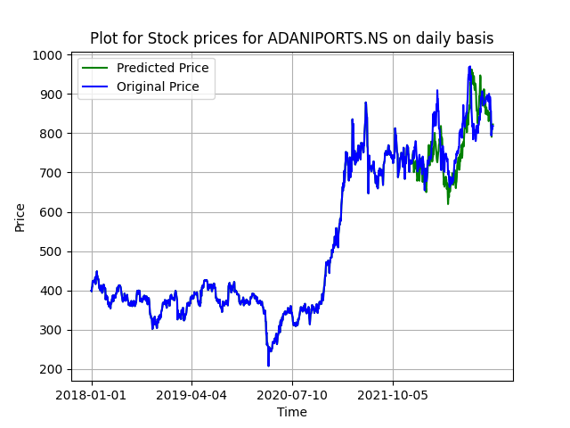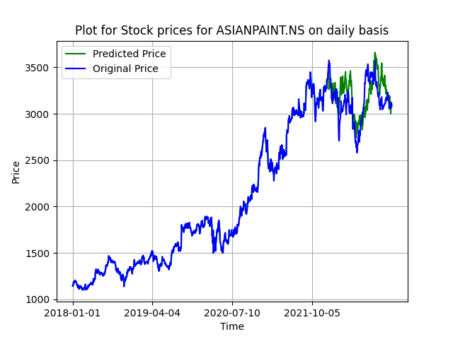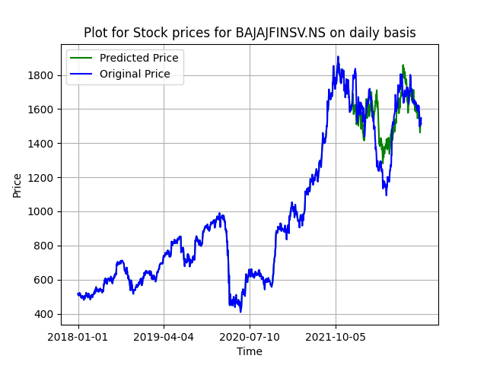

Now for Weekly and Monthly Returns the similar plots are :

For bsedata1:

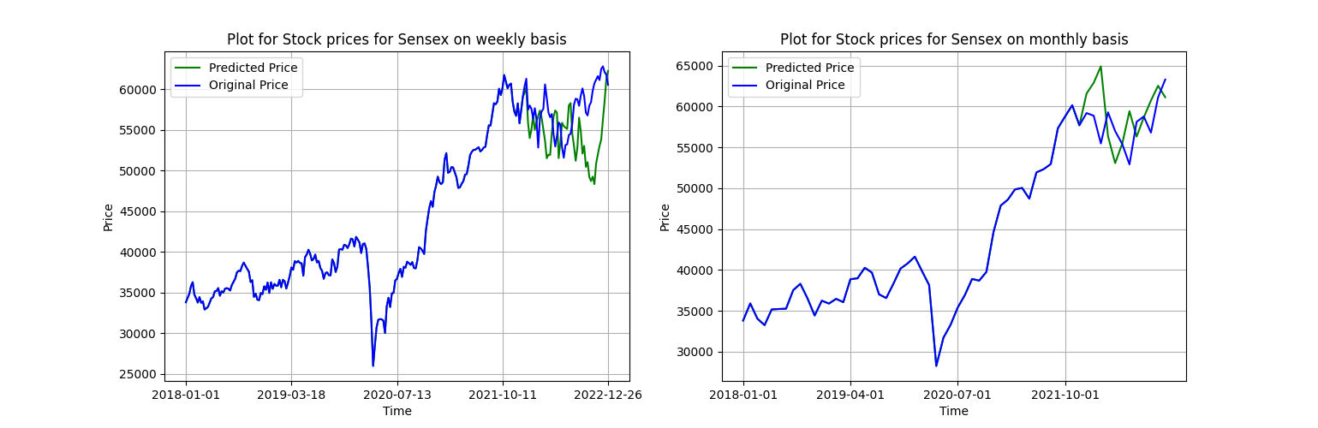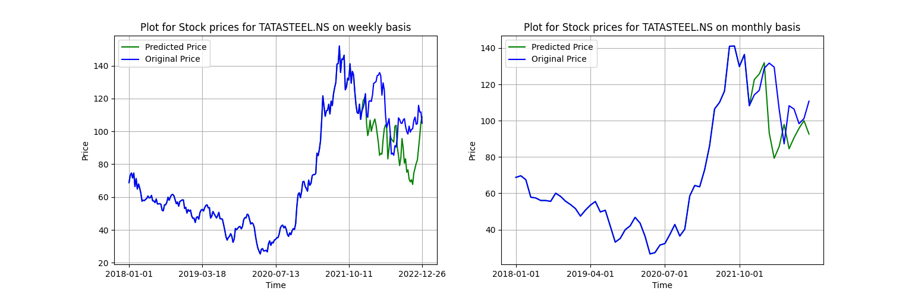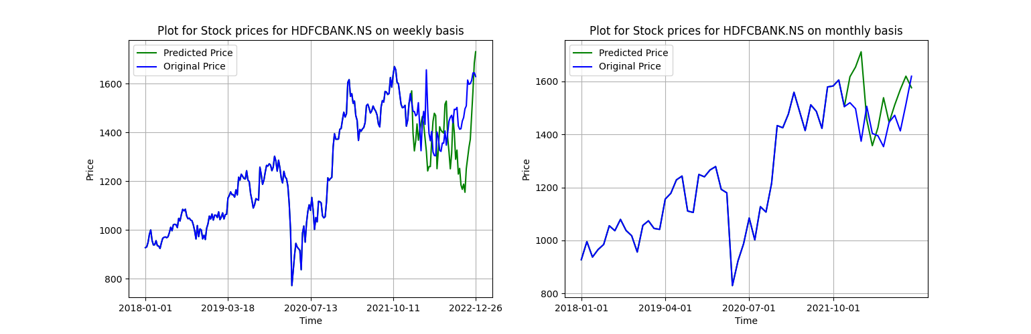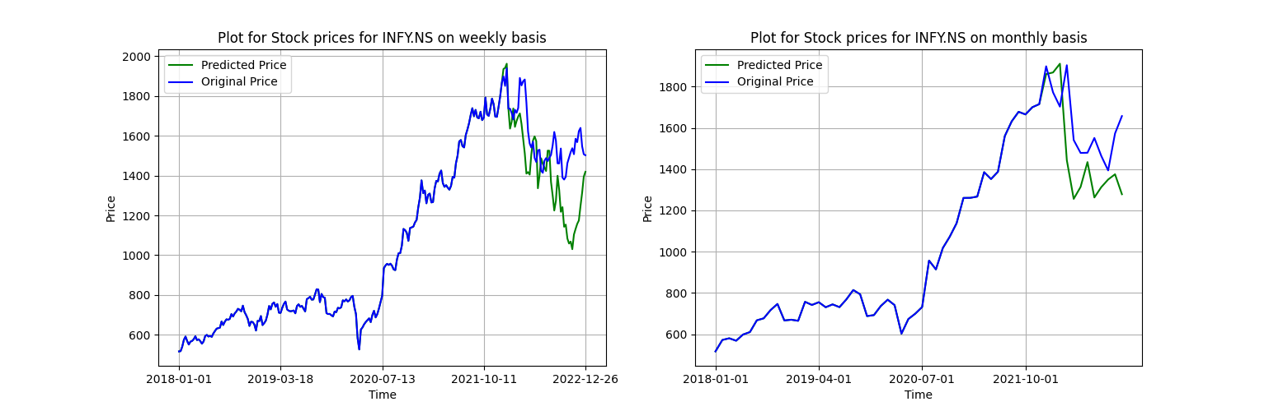

For nsedata1:

